CPSC 335 7/12/2021

- Project 1
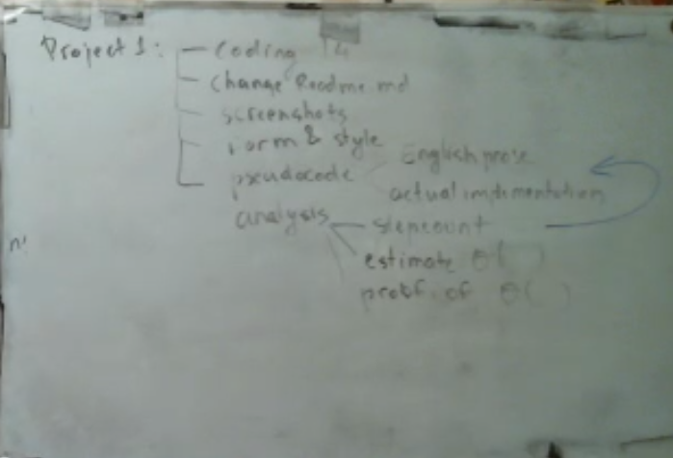

- Mock Exam
  - There will be Proctorio only for the Midterm and Final Exam
- Lecture
  - Big O Notation
    - time complexity given as O(n), O(n^2), etc. to describe the relationship between time and computation of an algorithm
  - Ex. O(g(N) = {set of all functions such that there exist two constraints C>) and N>) and f(N) <= (g(N) fN>Not.
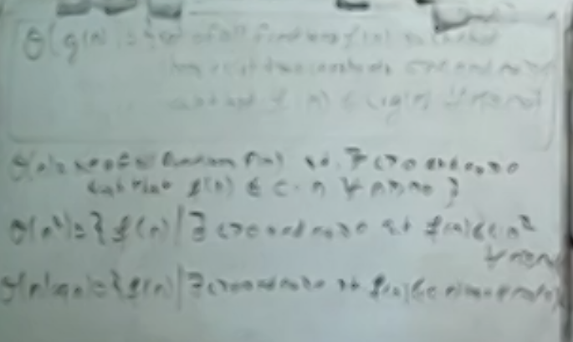
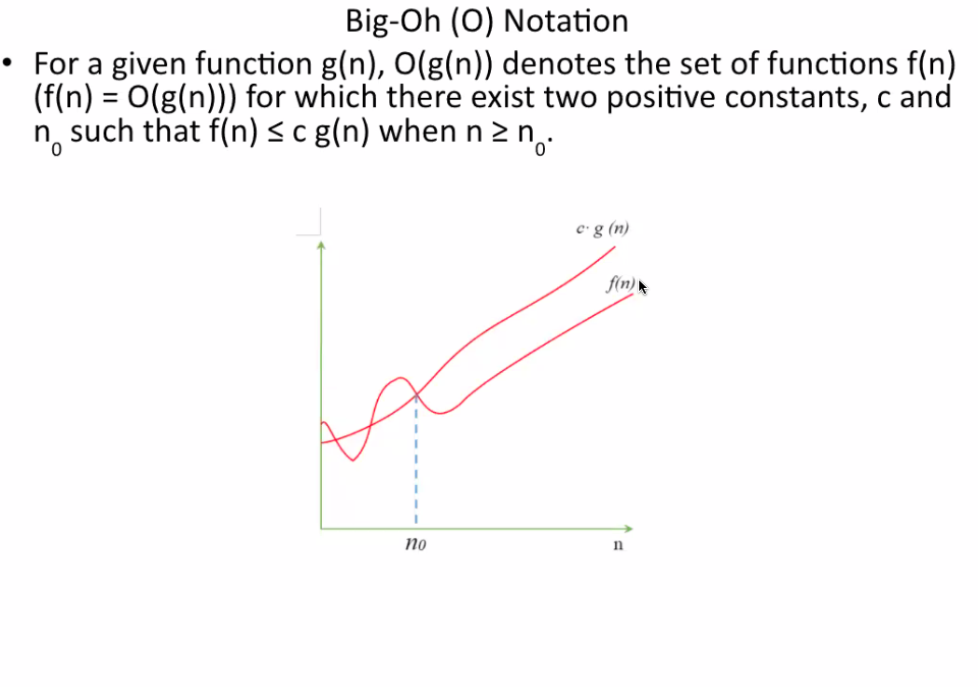
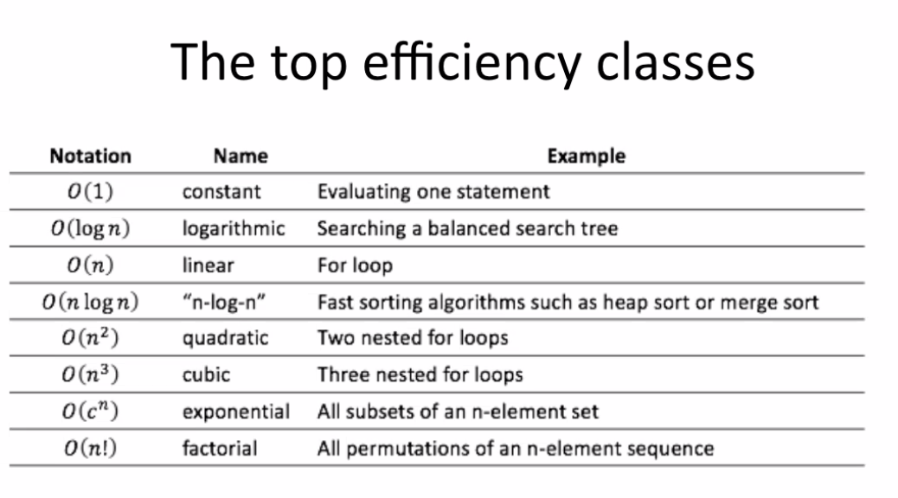
- The top efficiency classes
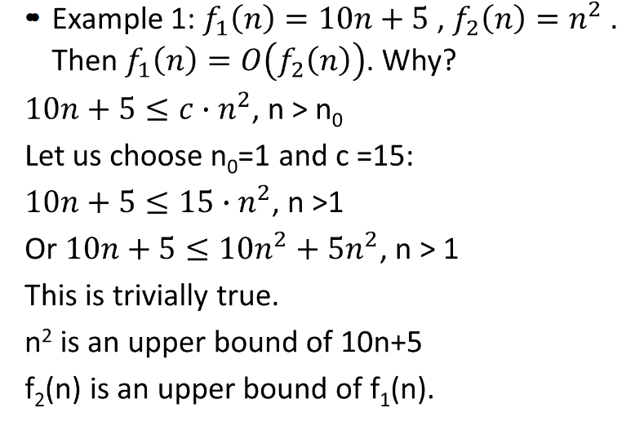
- Example 1:
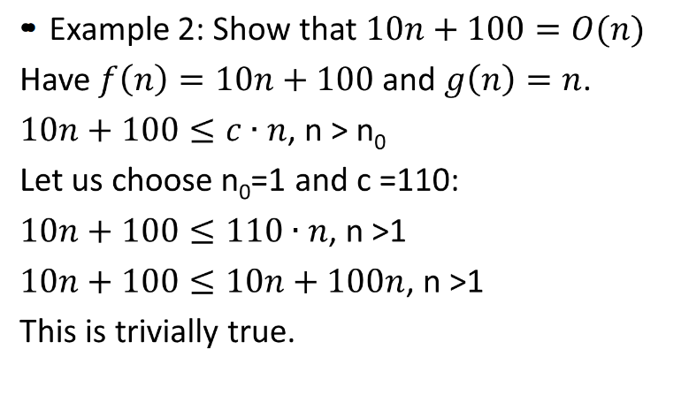
- Example 2
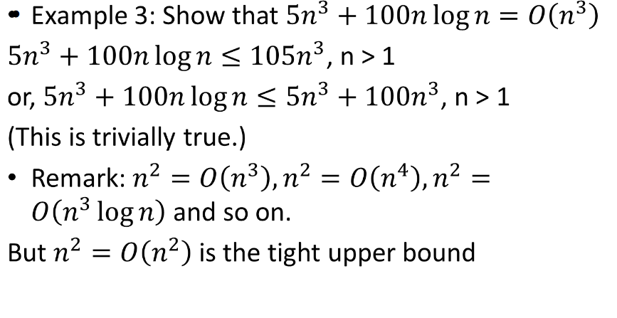
- Example 3:
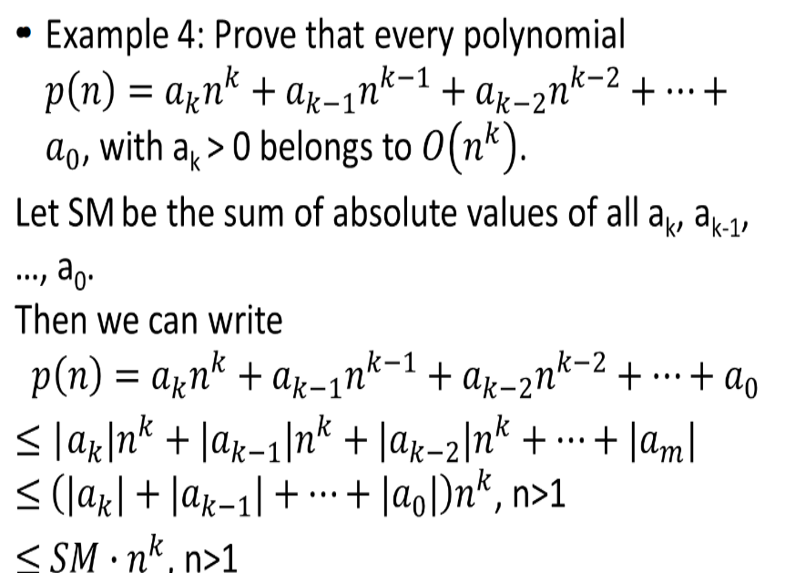
- Example 4
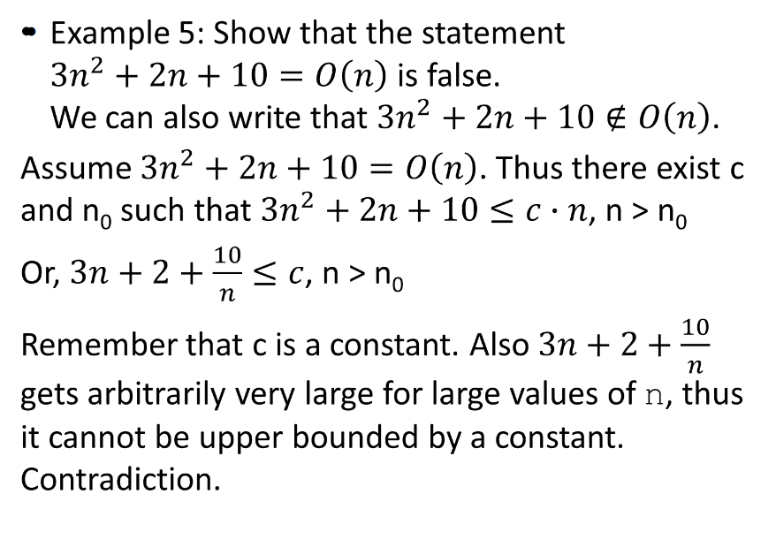
- Example 5

- Example 6:
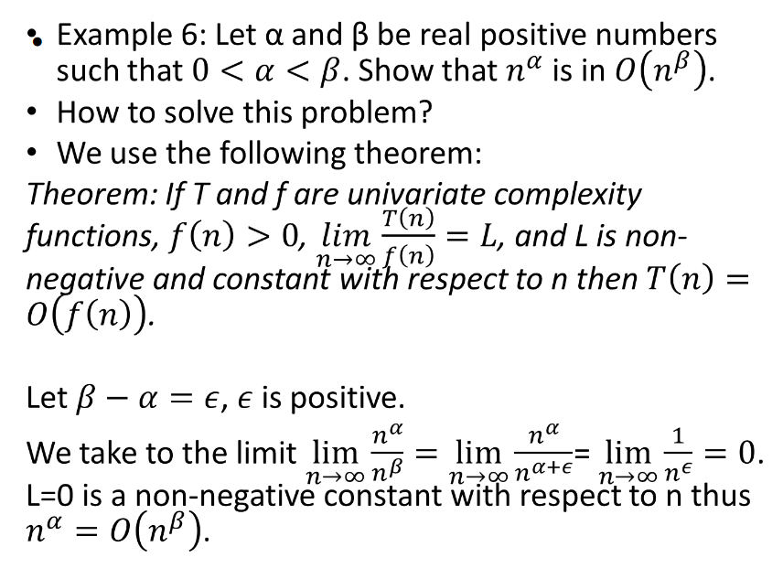
- Using Limits, show that:
